Measurement Protocol PAX

# General Information:

|  |  |  |
| --- | --- | --- |
| Test date: 14/08/20 | Date prev. test: | Test number: 1 |
| Tested by: Sarah Schoultz | PAX number: PB-035 | Installed at ant.: |
| Comments: | | |
|  | | |
|  | | |
|  | | |
| Known problems: Bumpy and sloping X passband | | |
|  | | |
|  | | |
|  | | |

# Setup:

|  |  |  |  |
| --- | --- | --- | --- |
| Power supply: | OK 🗹 NOK 🗆 | Communication: | OK 🗹 NOK 🗆 |
| Supply current +6V: 1.110mA | | ssh obs@antcntl | |
| Supply current -6V: 0.115mA | | ssh ataant@paxtester | pw: q@n@t |
| Supply current +5V: 0.321mA | | telnet pax | “help” |
|  | | CTRL + ] | “close” |

# RF Test with VNA:

### VNA Setup:

|  |  |  |
| --- | --- | --- |
| Load configuration: Passband_PAX.csa | | |
| Freq Start: 1.0 GHz | Freq Stop: 13.0 GHz | Power Level: -20 dBm |
| Averaging: enabled | Averaging count: 15 | N. Points: 801 |
| VNA : Agilent N5230C 10MHz - 20GHz | | |

|  |  |  |  |  |
| --- | --- | --- | --- | --- |
| VNA to PAX connection: | 1m ABC-CA18 Cable + 20dB Attenuator | | | |
| Input Power Level to PAX: (Measured) | @1GHz:  -40.2dBm | @4GHz:  -40.7dBm | @8GHz: -41.2dBm | @12GHz: -41.4dBm |

|  |  |
| --- | --- |
| PAX to VNA connection: | 2m Fibre Cable + Fibre Diode + AOX Amplifier + 1m ABC-CA18 Cable |

### Measured Passband with Attenuator set to 7dB each (Complete Link):

|  |
| --- |
| X |

|  |  |  |  |
| --- | --- | --- | --- |
| Flatness: | OK 🗆 NOK 🗹 | Unwanted Features: | Yes 🗹 No 🗆 |

|  |
| --- |
| Y |

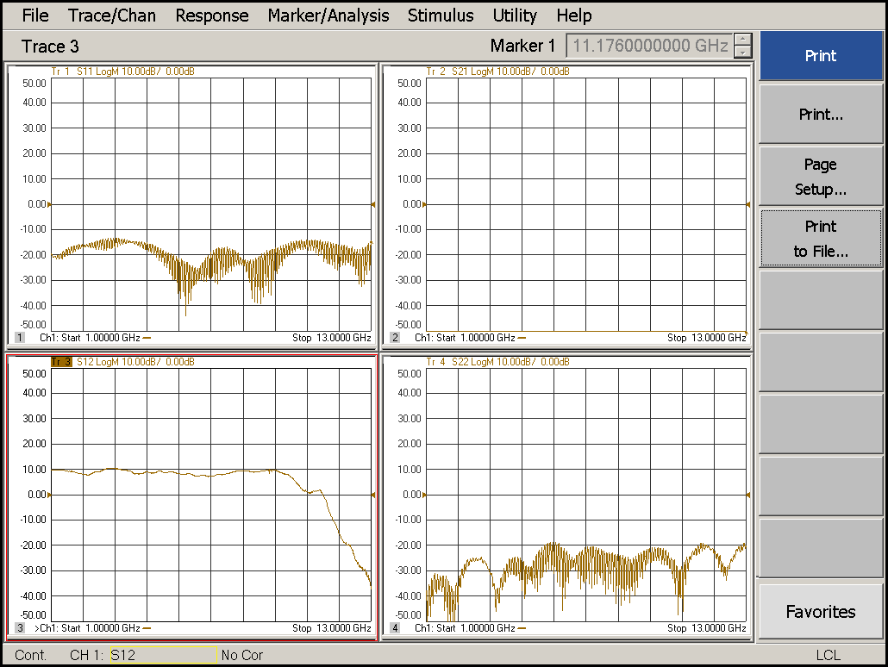

|  |  |  |  |
| --- | --- | --- | --- |
| Flatness: | OK 🗹 NOK 🗆 | Unwanted Features: | Yes 🗆 No 🗹 |

### Power Sweep (Complete Link):

|  |  |  |
| --- | --- | --- |
| Load configuration: Power_Sweep_PAX.csa | | |
| Power Start: -40dBm | Power Stop: -20dBm | Frequency : 4.0GHz |
| PAM Attenuator: 0dB |  | N. Points: 801 |

|  |
| --- |
| X |

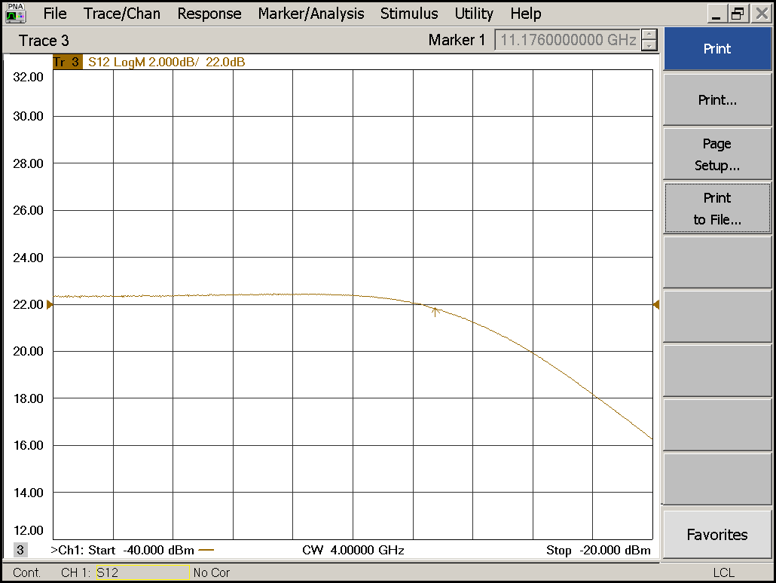

|  |  |  |  |
| --- | --- | --- | --- |
| Compression point: | OK 🗹 NOK 🗆 | Unwanted Features: | Yes 🗹 No 🗆 |

|  |
| --- |
| Y |

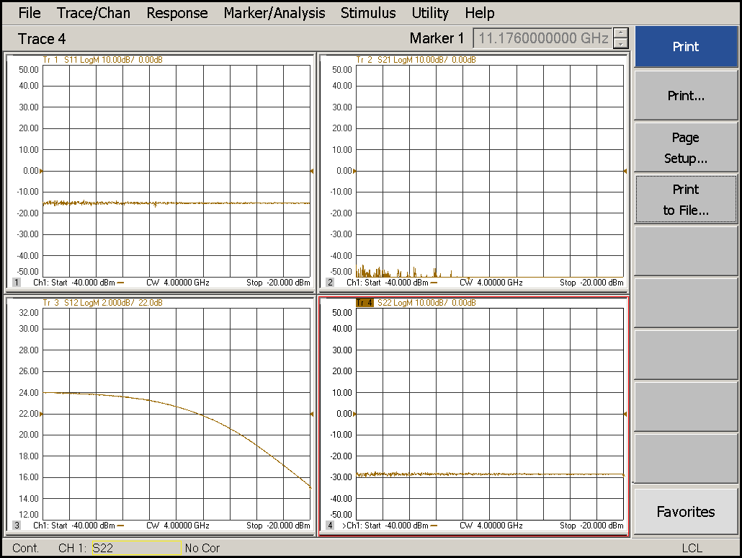

|  |  |  |  |
| --- | --- | --- | --- |
| Compression point: | OK 🗹 NOK 🗆 | Unwanted Features: | Yes 🗆 No 🗹 |

### Detector Calibration and Attenuator Sweep Pol X:

|  |  |  |
| --- | --- | --- |
| Load configuration: Detector_Calibration_PAX.csa | | |
| Freq : 4.0 GHz | Power Level: -20dBm | Sweep Time: -20sec |
| Sweep Mode: CW | Power Level at PAX Input (Measured): -40.6dBm | |

|  |  |  |  |  |
| --- | --- | --- | --- | --- |
| X | | | | |
| CW Input Power [dBm]: | Attenuator Value A [dB]: | Attenuator Value: B [dB]: | Detector Value: | Power Meter  Value [dBm]: |
| -40.6 | 0 | 0 | - | 14.2 |
| -40.6 | 0 | 3 | - | 14.1 |
| -40.6 | 0 | 6 | - | 12.7 |
| -40.6 | 0 | 9 | 0.8607 | 10.2 |
| -40.6 | 0 | 12 | 0.6875 | 7.2 |
| -40.6 | 0 | 15 | 0.4327 | 4.4 |
| -40.6 | 0 | 18 | 0.2339 | 1.1 |
| -40.6 | 0 | 21 | 0.1297 | -1.9 |
| -40.6 | 3 | 21 | 0.0635 | -5.3 |
| -40.6 | 6 | 21 | 0.0331 | -8.3 |
| -40.6 | 9 | 21 | 0.0174 | -11.3 |
| -40.6 | 12 | 21 | 0.0094 | -14.2 |
| -40.6 | 15 | 21 | 0.0053 | -17.2 |
| -40.6 | 18 | 21 | 0.0031 | -20.5 |
| -40.6 | 21 | 21 | 0.0021 | -23.5 |
| -40.6 | 24 | 21 | 0.0016 | -26.3 |
| -40.6 | 27 | 21 | 0.0014 | -29.4 |
| -40.6 | 30 | 21 | 0.0013 | -32.5 |
| -40.6 | 30 | 24 | 0.0012 | -35.1 |
| -40.6 | 30 | 27 | 0.0012 | -37.6 |
| -40.6 | 30 | 30 | 0.0011 | -39.9 |

|  |  |  |
| --- | --- | --- |
| Use Noise Source: Atlantic AS6333 | | |
| Freq : 1.0 - 12.0GHz | Power Level: -41.8dBm |  |
| DC Supply: 28V |  | |

|  |  |  |  |  |
| --- | --- | --- | --- | --- |
| X | | | | |
| Input Power [dBm]: | Attenuator Value A [dB]: | Attenuator Value: B [dB]: | Detector Value: | Power Meter  Value [dBm]: |
| -41.8 | 0 | 0 | - | 12.5 |
| -41.8 | 0 | 3 | - | 11.4 |
| -41.8 | 0 | 6 | - | 9.6 |
| -41.8 | 0 | 9 | 0.8601 | 7.4 |
| -41.8 | 0 | 12 | 0.7986 | 4.6 |
| -41.8 | 0 | 15 | 0.5165 | 2.0 |
| -41.8 | 0 | 18 | 0.2817 | -1.2 |
| -41.8 | 0 | 21 | 0.1584 | -4.1 |
| -41.8 | 3 | 21 | 0.0870 | -7.1 |
| -41.8 | 6 | 21 | 0.0447 | -10.2 |
| -41.8 | 9 | 21 | 0.0239 | -13.0 |
| -41.8 | 12 | 21 | 0.0126 | -16.0 |
| -41.8 | 15 | 21 | 0.0074 | -18.7 |
| -41.8 | 18 | 21 | 0.0043 | -22.0 |
| -41.8 | 21 | 21 | 0.0029 | -25.1 |
| -41.8 | 24 | 21 | 0.0021 | -28.1 |
| -41.8 | 27 | 21 | 0.0019 | -31.0 |
| -41.8 | 30 | 21 | 0.0017 | -34.2 |
| -41.8 | 30 | 24 | 0.0016 | -36.7 |
| -41.8 | 30 | 27 | 0.0016 | -38.9 |
| -41.8 | 30 | 30 | 0.0015 | -40.9 |

### Detector Calibration and Attenuator Sweep Pol Y:

|  |  |  |
| --- | --- | --- |
| Load configuration: Detector_Calibration_PAX.csa | | |
| Freq : 4.0 GHz | Power Level: -20dBm | Sweep Time: -20sec |
| Sweep Mode: CW | Power Level at PAX Input (Measured): -40.6dBm | |

|  |  |  |  |  |
| --- | --- | --- | --- | --- |
| Y | | | | |
| CW Input Power [dBm]: | Attenuator Value A [dB]: | Attenuator Value: B [dB]: | Detector Value: | Power Meter  Value [dBm]: |
| -40.6 | 0 | 0 | - | 14.0 |
| -40.6 | 0 | 3 | - | 13.9 |
| -40.6 | 0 | 6 | - | 12.5 |
| -40.6 | 0 | 9 | 0.8512 | 9.8 |
| -40.6 | 0 | 12 | 0.7067 | 6.9 |
| -40.6 | 0 | 15 | 0.4432 | 4.1 |
| -40.6 | 0 | 18 | 0.2429 | 0.8 |
| -40.6 | 0 | 21 | 0.1346 | -2.3 |
| -40.6 | 3 | 21 | 0.0676 | -5.5 |
| -40.6 | 6 | 21 | 0.0350 | -8.5 |
| -40.6 | 9 | 21 | 0.0183 | -11.6 |
| -40.6 | 12 | 21 | 0.0098 | -14.6 |
| -40.6 | 15 | 21 | 0.0058 | -17.5 |
| -40.6 | 18 | 21 | 0.0035 | -20.8 |
| -40.6 | 21 | 21 | 0.0023 | -23.9 |
| -40.6 | 24 | 21 | 0.0019 | -26.8 |
| -40.6 | 27 | 21 | 0.0017 | -29.8 |
| -40.6 | 30 | 21 | 0.0015 | -33.1 |
| -40.6 | 30 | 24 | 0.0015 | -35.6 |
| -40.6 | 30 | 27 | 0.0014 | -38.1 |
| -40.6 | 30 | 30 | 0.0014 | -40.3 |

|  |  |  |
| --- | --- | --- |
| Use Noise Source: Atlantic AS6333 | | |
| Freq : 1.0 - 12.0GHz | Power Level: -41.8dBm |  |
| DC Supply: 28V |  | |

|  |  |  |  |  |
| --- | --- | --- | --- | --- |
| Y | | | | |
| Input Power [dBm]: | Attenuator Value A [dB]: | Attenuator Value: B [dB]: | Detector Value: | Power Meter  Value [dBm]: |
| -41.8 | 0 | 0 | - | 12.2 |
| -41.8 | 0 | 3 | - | 11.1 |
| -41.8 | 0 | 6 | - | 9.3 |
| -41.8 | 0 | 9 | 0.8504 | 7.1 |
| -41.8 | 0 | 12 | 0.8429 | 4.4 |
| -41.8 | 0 | 15 | 0.5647 | 1.8 |
| -41.8 | 0 | 18 | 0.3127 | -1.3 |
| -41.8 | 0 | 21 | 0.1769 | -4.3 |
| -41.8 | 3 | 21 | 0.0978 | -7.3 |
| -41.8 | 6 | 21 | 0.0501 | -10.4 |
| -41.8 | 9 | 21 | 0.0268 | -13.2 |
| -41.8 | 12 | 21 | 0.0140 | -16.3 |
| -41.8 | 15 | 21 | 0.0086 | -19.0 |
| -41.8 | 18 | 21 | 0.0048 | -22.3 |
| -41.8 | 21 | 21 | 0.0034 | -25.4 |
| -41.8 | 24 | 21 | 0.0025 | -28.4 |
| -41.8 | 27 | 21 | 0.0022 | -31.1 |
| -41.8 | 30 | 21 | 0.0020 | -34.4 |
| -41.8 | 30 | 24 | 0.0018 | -36.9 |
| -41.8 | 30 | 27 | 0.0019 | -39.0 |
| -41.8 | 30 | 30 | 0.0019 | -41.0 |

# Inspection:

### Visual:

|  |  |  |
| --- | --- | --- |
| Fibre Connectors Clean | Comments: | OK 🗹 NOK 🗆 |
| Fibre Connector Mechanical | Comments: | OK **🗹** NOK **🗆** |
| RF Cable | Comments: | OK **🗹** NOK **🗆** |
| RF Connectors Clean | Comments: | OK **🗹** NOK **🗆** |

### Functions:

|  |  |  |
| --- | --- | --- |
| Read Temperature Value | Comments: 38.1 | OK 🗹 NOK 🗆 |
| LNA Settings | Comments: | OK**🗹** NOK **🗆** |
| Temperature Stabilisation | Comments: | OK 🗆 NOK **🗆** |
|  |  | OK 🗆 NOK **🗆** |